Chapter Eight
The Dallas Community Resource Unit

Section One:

Baseline Social and Economic Information

Community Description

Geographic Features

The Dallas Community Resource Unit (CRU) is shown in Figure 22. It extends north of the Polk County line south of Amity, west at a line between Falls City and Dallas, south to the Four Corners area toward Monmouth, and east generally along the Willamette River west of Salem. It includes the community of Rickreall.

Settlement Patterns

Dallas was incorporated in 1876. It had a population of 9,902 in 1990 and 12,459 in 2000, an increase of 21% (Census Data, Table Two). It is well-known in Oregon settlement history as the ending of the Applegate Trail. The three Applegate brothers, Lindsay, Jesse, and Charles, began the trail as a spur to the Oregon Trail in 1846. After losing family members to the waters of the Columbia River, they sought a safer route in to the Willamette Valley. This spur came in from Winnemucca, Nevada into southern Oregon and north to Dallas along the westside of the Willamette Valley. A number of parks, rest areas, and schools are named Applegate in this area. Figure Two shows a photo of the Polk County Courthouse, built in 1859.

Dallas is about 10 miles southwest of Salem on Highway 223. Outside of town there are a number of rye grass seed farms with many houses scattered about the rolling hillsides. Rickreall Creek divides the city. North Dallas is on one side of the creek and is the oldest part of town.
The city begins on the top of a hill. From this viewpoint, once can see larger hills to the west against which the city appears to be settled. On top of this
Figure 22
Map of the Dallas Community Resource Unit

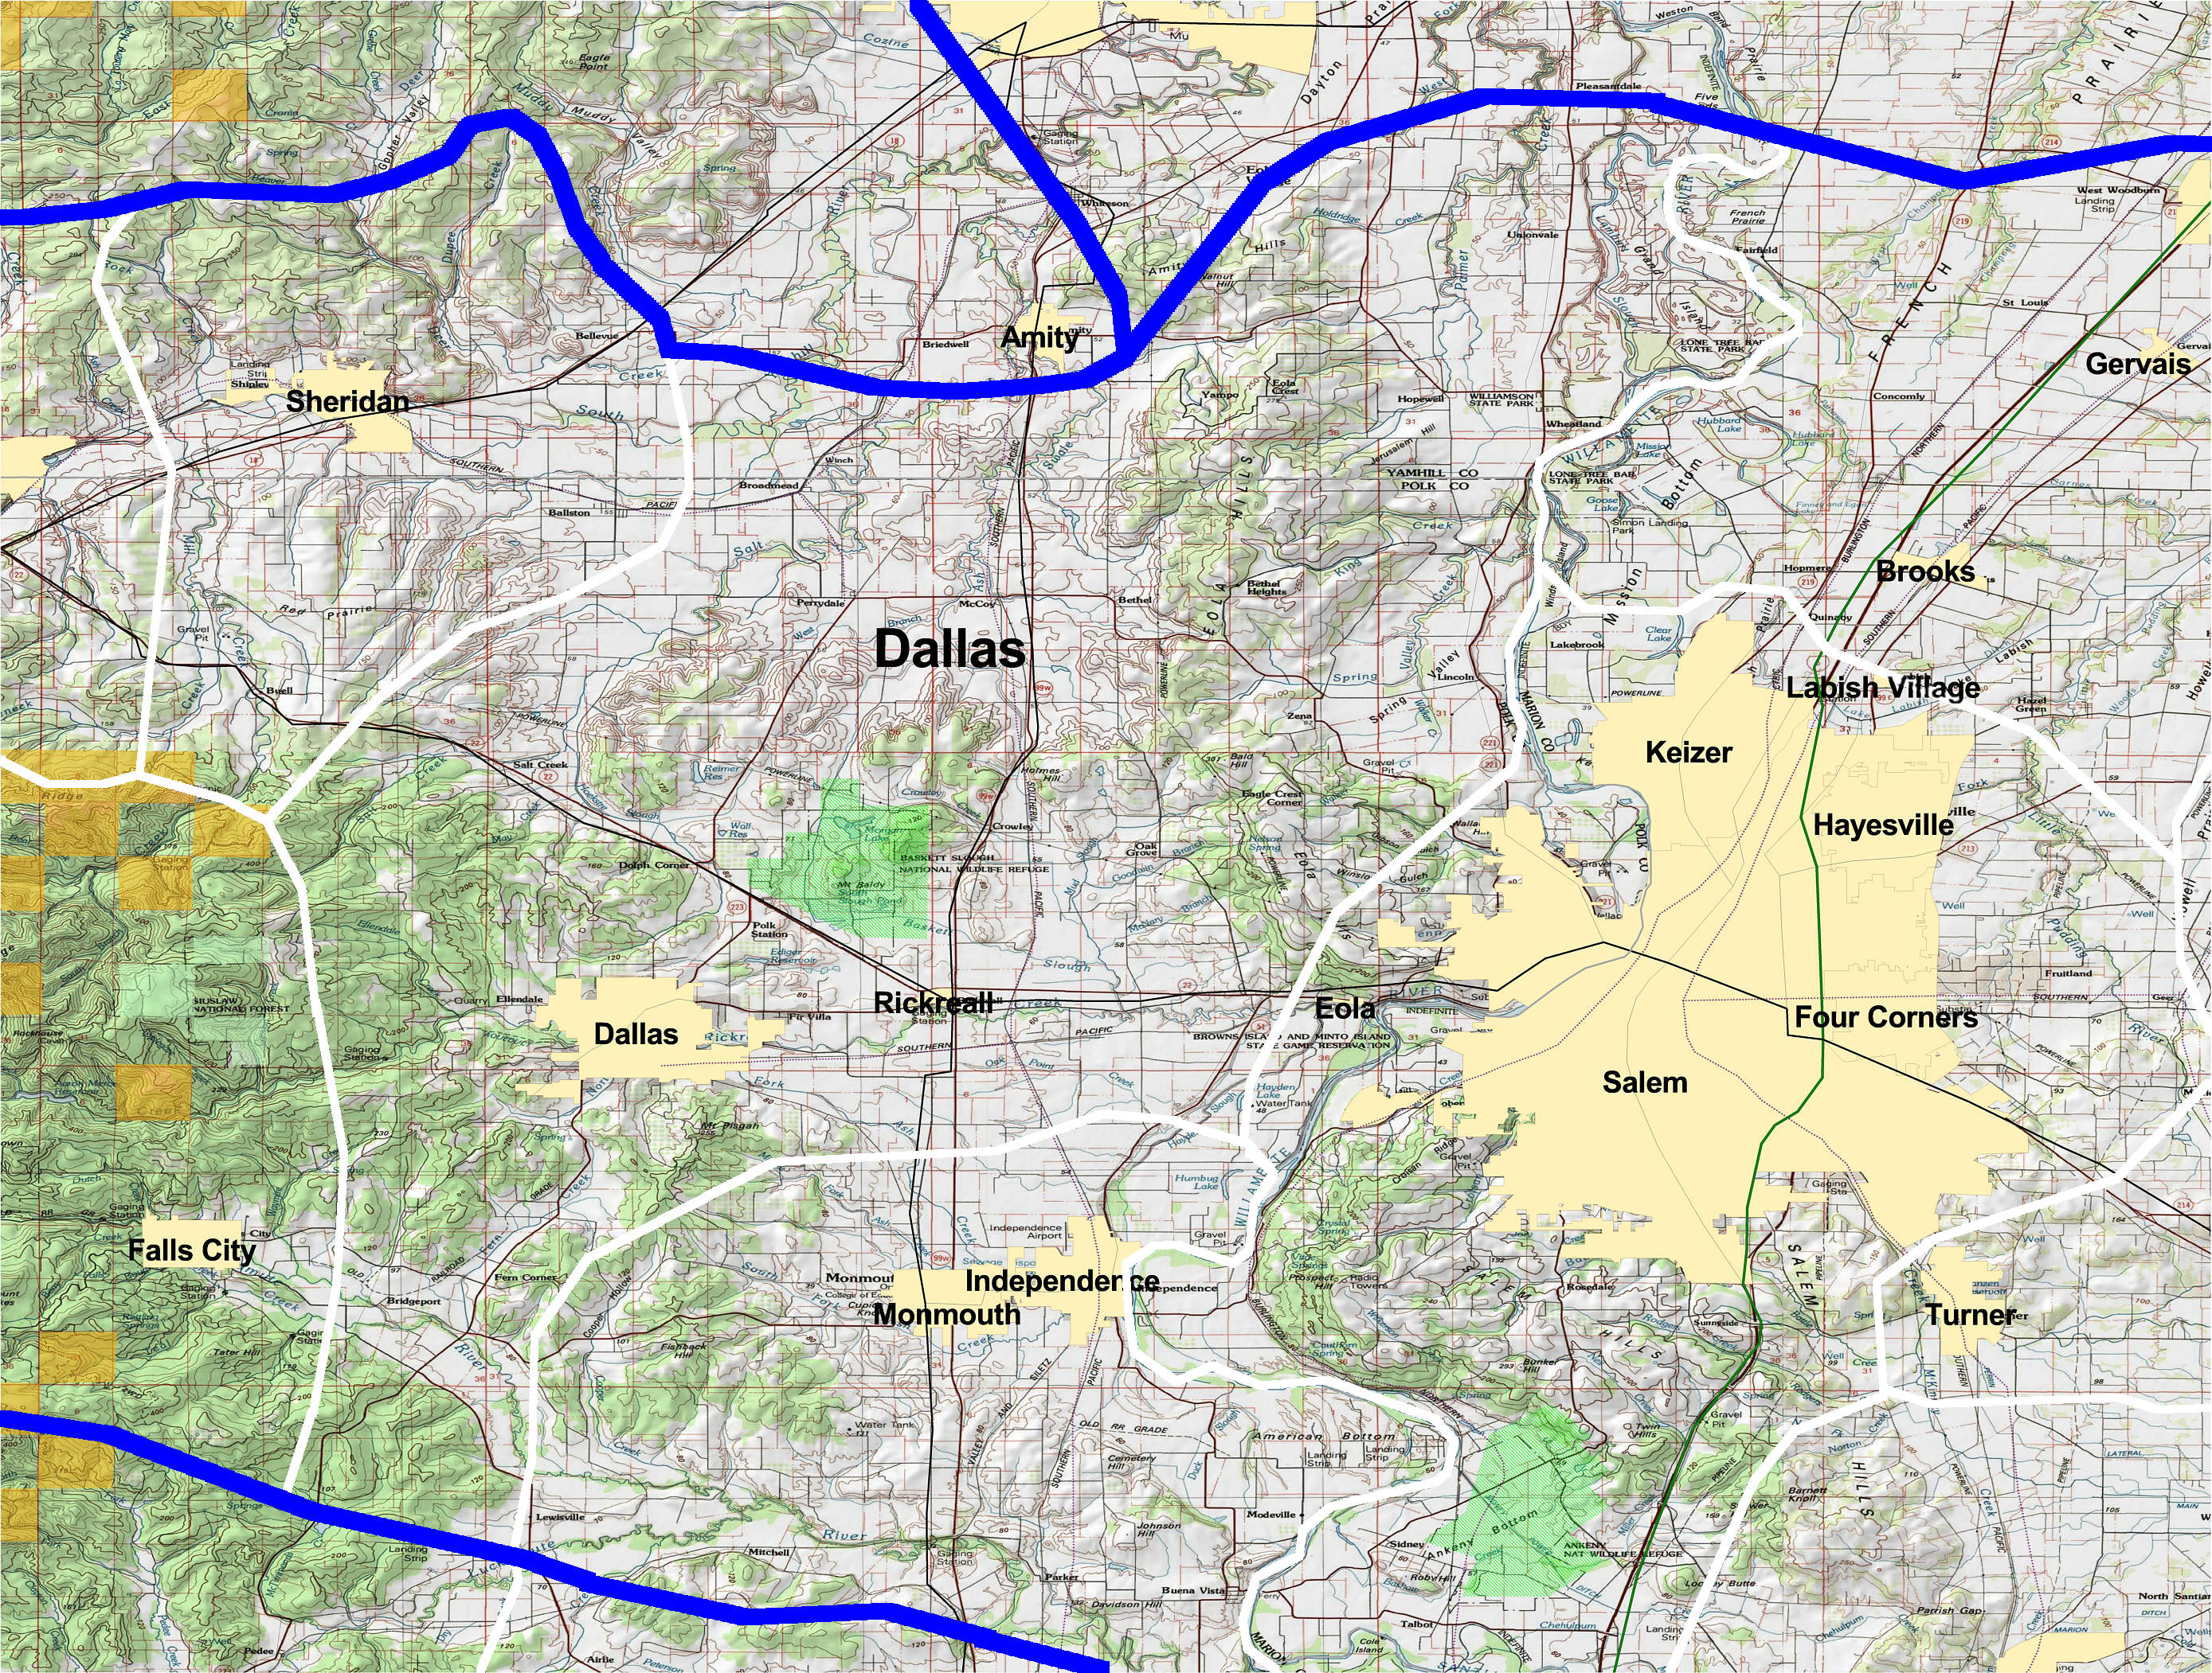

Figure 23
Polk County Courthouse in Dallas, Built in 1859

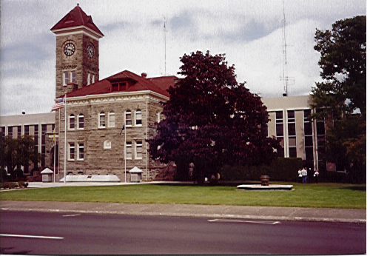

hill, there is also new shopping—Wal-Mart, Safeway and Rite-Aid. Down the sloping hill to the southwest outside of town, the highway reveals a significant amount of very expensive homes, old trailers, and small homes in need of repair. The road toward Monmouth is flat and has a few tree farms, but the area is predominated by seed grass.

Farmers outside of town are reportedly selling portions of their land for high-end houses to be built. Evidence of this style of settlement is already evident south of town, where gigantic homes are being built. The building is not so restricted as in Amity, for instance, but they are attempting somewhat to control growth by only issuing 125 building permits a year. Recently, some developments have spring up on the northeast and east central area of town. They are medium priced homes that typically are occupied by families who work in Salem and have either moved from Salem or from California. The more relaxed growth controls have raised concerns over the ability for the Rickreall Watershed to provide increasing water demands. Inter-county collaborations are beginning over this issue.

“I’ve been here 40 years, but I’m going to move out farther because of all the housing that has come in near me. It’s losing its charm. I have some friends that have moved recently out to county lands and they like it.”

“This is an excellent community because of its livability. It has low crime, a great library, a senior center, supported schools, and good public works. Our daughter has stayed and is raising her son here because of that, even though she lives in Salem.”

“We moved here six months ago from Corvallis so that my husband and I could be closer to our grandchildren. It’s a very welcoming town. I have already made friends.”

Publics

The key social segments of the community include farmers, commuters, business people, oldtimers and newcomers, youth, and retired people. Very few minority people were observed. Latinos are growing as a proportion of the population but they still tend to be invisible in this area. For example, they were not noted in government offices, public facilities, and stores. Latinos are not moving through the community like years ago, but they are settling, working at nurseries outside of town or in the local vineyards.

Networks

See Section Two.

Work Routines

For a long time, Dallas was a mill town. The mill is still operational but has cut back on employees. It has changed from a Willamette Industries mill to a Weyerhaeuser mill. Willamette Industries started in Polk County as the Willamette Valley Lumber Company in 1906, and has had a long and important presence in the community. Its loss was an active topic of conversation. However, according to local residents, the amount of land holdings Weyerhaeuser has in this area makes it unlikely that the mill will close anytime soon.

Although Dallas is no longer a “mill town,” a sector of the economy is still dependent on natural resources from public lands, including mill workers, loggers, and gatherers of special forest products. Residents stated that other manufacturing, such as tractor, recreational vehicle and others, have not lasted long and that hundreds of people have been laid off. The City administration listed the following employers, with the number of employees included, as important for Dallas citizens:

Praegitzer Industries, Inc., Circuit boards 663
Willamette Industries, Plywood and lumber 252
Balderson, Inc., Caterpillar machine parts 114
Dallas Planing, Finished wood products 27
Westview Products, Specialty wood products 20
Source: Community Profile, Oregon Economic and Community Development Department, 2002.

Tyco Printed Circuit Group acquired Praegitzer Industries and currently has 375 workers.

Most of the farms nearby are rye grass, although a dairy out of town has 1,000 cows. There are also a few vineyards and tree farms in the surrounding areas.

People in this community rely on commuting to Salem for livelihood. We heard variations on the comment below several times during our stay in the community:

“I can make it to Salem in less time than it takes to drive through Salem.”

The town is in transition from a manufacturing-based economy to a service economy as people find work in Salem and live in Dallas. Although the downtown has some empty store fronts, the quaint beauty of the courthouse and the downtown has real potential to compete with large corporate stores outlying the city to the north of town.

“It’s hard to own a small business in a small town.”

Support Services

This area of Polk County has become a “Service Integration” site, one of several in the state designed to promote more efficient delivery of services among social service agencies. Agency people reported that it has worked very well, that Polk County has a reputation of working together well, and that its mission of streamlining services is being realized.

4-H and Kids, Inc. were cited as being very active. Kids Inc. was well regarded in the community. It is located in the old library near downtown and had 2200 registrations last year. “Practically every child in town plays one sport or another through us,” a staff person stated. Kids Inc. also serves as an informal service broker, directing parents about where to get immunization shots, cheap hair cuts, and so on.

Church youth groups are very popular in town and a Christian coffee house/ bookstore in Dallas is also very popular. There is a senior center and two assisted living homes in town. A bus runs through Dallas to Salem and Portland.

The Food Bank reported being “swamped” with cases since Tyco (printed circuits) laid off workers during the last year and one-half. The Marion-Polk Gleaners serve about 800 families a week with food and other essentials, depending on volunteers gathering up left over produce in the fields. This group received the “Outstanding Organization” award from the City of Dallas this year.

A number of residents cited increased cooperation between other towns in recent years that has netted benefits for all parties. Collaboration between the schools and in a tourist pamphlet between Dallas, Monmouth and Independence was cited as evidence of more collaboration.

“Salem more and more is becoming our commercial competition. We knew if we didn’t work together, we would not do so well.”

Dallas residents were very proud of the Dallas City Park, referring our team members to it regularly. It has nearly 40 acres—six playgrounds, an arboretum, and Rickreall Creek. In addition, East Dallas Community Park is 17 acres and includes a modern aquatic center, soccer and softball fields, tennis courts and skateboard facility. Polk County Museum, local wineries and the Spirit Mountain Casino, in Grand Ronde, 20 miles west of Dallas, are local attractions as well.

The Dallas community is active in supporting its youth through a number of different programs. Dallas Action Together, for example, offers small grants for people and organizations that provide youth activities, reduce substance abuse, and enhance positive relationships between youth and adults.

Recreational Activities

Refer to Section Three.

B. Trends, and Citizen Issues

Related to Community Life

Trends

The Dallas and Salem economies are intertwined, with some people living in Salem and working in Dallas, and others living in Dallas and working and Salem.

The Dallas City Council is considering expanding the urban growth boundary to accommodate growth and new business. Industrial development is likely to happen to the east of the city.

Community Issues

Governance

Polk County Commissioners, as well as Dallas city officials, are lobbying for Highway 22 improvements to address safety hazards near Dallas.

Dallas city government is taking steps to foster more industrial, commercial development and multi-family housing through planning, and expanding its urban growth boundary. This interest is hampered somewhat by the Exclusive Farm Use (EFU) land designation currently in place through Polk County, which creates countervailing pressure to preserve farm lands.

Water availability is an issue that affects Dallas, as well as other communities in this area. They are looking to acquire water from Adair Village, which, as an old military base, has huge water rights.

Recreation

“It used to cost a buck to get in the pool. Now it’s $5. A lot of people can’t afford that. Now kids have no place to hang.”

Agriculture

“I’m beginning to sell out my land because I can’t afford to farm anymore.”

Section Two:

Communication Strategies

A. Informal Networks and Communication

Gathering Places

North Dallas Bar and Grill
Murphy’s Grill
JJ Sweet Shop
McDonalds, for seniors and farmers
The Place Café is a place frequented for forestry people and farmers.
Guthrie Park is host to a country jam session on Friday nights.

Key Community Contacts

Old family names are still important in Dallas—the Woods, Bevens and Lambs.

The Lamb family recently received the “First Family” award by the City of Dallas to honor families involved in community affairs for more than one generation.

Delbert Hunter is a well-respected 83-year-old gentleman known for conservation efforts. The public arboretum is named after him, as is a local environmental group (see below).

Kids Inc. interacts with a large number of parents in the community. The organization would be extremely useful in bridging to families and children.

Walt Miller, well-regarded outdoorsman (see below)

B. Formal Groups and Communication

Figure 24

Organizations With Interest in Public Lands in the Dallas Area

Organization | Contact Information | Mission
Friends of Delbert Hunter |  | Clean up projects on Rickreall Creek
Very Active Outdoor Club | Ron Crebs,  503-623-5844  Walt Miller,  503-623-3631 | Proved that salmon and stealhead runs exist on Rickreall
Rickreall Watershed Council | Nancy Lamb  580 Main Street Suite A  Dallas, Oregon 97338  (503) 623-9680 ext. 110 | Watershed restoration
Dallas High School Environmental Youth Group | Stephanie Preuitt  503-623-8336 | Clean up of local camping areas; Greening the school;  Annual creek clean-up  Bluebird boxes in coastal range.
Luciaymute Environmental Association | Bob Reed  (503) 623-4007  404—not called?
Dallas Sportsman’s Club | Walt Miller  (503) 623-3631 | A variety of environmental projects; Transporting smolt up the creek during drought; prevented further damning of the Rickreall by videotaping spawning Coho salmon; plant hatch boxes in the river near Hebo for Chinooks; fishing derby; stream enhancement
Ash Creek Water Control Board | (503) 838-0925
Dallas Chamber of Commerce | 580 Main St., Suite C, Dallas, OR 97338 (503) 623-2564

Section Three:

The Public Lands Perspective

A. Uses of and Orientation to Public Lands

It is clear that Dallas people as a whole are not very outdoor oriented—they may have been in the timber past, but not currently. Although the forest is used, people are more directed toward urban areas for entertainment. Popular activities for townspeople include Spirit Mountain Casino, only a twenty-minute drive.

“This town has changed so much, I really don’t know where people go on the weekends.” [logger]

Hunting and fishing are done by a segment of the population, but the activity is not as pronounced as other communities, nor did practitioners express strong recreation issues. Boats and RVs in Dallas numbered less than other communities also. Outdoor spots include Cascade High Lakes, Detroit Lake, and coastal areas. It is evident from local descriptions that the Cascades are not used as much by people west of the Interstate 5 as east. Moreover, often the Cascades are not a destination for people on the west side of the freeway.

“I spend three months a year hunting. I even do some reluctant guiding in the coastal range.”

A local destination is “The Valley of the Giants,” an old growth park managed by BLM. Many people reported that their favorite outdoor spots are too crowded now for enjoyment. Rather than go to places like Detroit Lake, many opt to continue on to northeastern Oregon.

When people used the forest, use patterns appeared to be related to income levels. The people with lower income levels tended to camp near the coast, in the Lincoln City area. If they choose to go east, they said they prefer the Mill City, Detroit Lake area. Some said that the Luckiamute, a river running south of town about 14 miles, was a local favorite.

Meanwhile, people who seemingly had more disposable income that accessed the forest tended to have a wide range of designations. Namely, the Cascade Lakes of central Oregon and the three reservoirs—Detroit, Foster and Green Peter. To the west, they have various destinations. Although many claimed they would hike in the forest, few said they camp on the coast.

Wal-Mart is the only sporting goods store in town and its staff was very uninformed about public lands, local camping, or outdoor activities in general.

Traditional people (loggers, mill workers, long time residents) knew that permits were necessary for gathering special forest products and they tended to know where to locate maps showing different property ownerships and how to use them. Newcomers and urbanites, on the other hand, tended not to be as aware of property ownership.

Some local residents still make their living from the forest, including horse logging and the collection of special forest products, including mushrooms, moss and native plants. The mushroom business is currently depressed because the weather patterns have made business unpredictable. It is primarily Mexicans who are doing foraging in the forest. They go as groups to pick; many are from Salem and Independence.

“I buy only dry moss in the summer. I sell the mushrooms I buy to ____ _____ in Portland.”

“I try to buy local mushrooms when I can for my business. Falls City is the chanterelle mushroom capital of the world. They have a festival every fall.” [The last festival apparently was 1999.]

The Rickreall Watershed Council has written a grant to put manufactured logjams on Rickreall Creek near the town to build up the embankment so that the creek won’t meander but still have a healthy riparian zone.

Dallas High School has an environmental club. A number of environmental groups are active in the area. And there are a number of events staged each year to accomplish environmental objectives or to raise awareness about environmental issues or just have fun. For example, Dallas hosts a festival each march called the “Shoot and Suck” which is archery target shooting and an oyster cookout. No other school programs were identified related to outdoor education or to getting children and youth in the forest.

The Sportsman’s Club has been in existence for over a hundred years. They were about the first group to become involved in the state-sponsored STEP program for spawning fish. It is a loose knit group that “just does stuff” and avoids “getting into the bureaucratic mode.” They have done numerous habitat projects over the years in Rickreall Creek in conjunction with the City, scouts, and other kids. The group used videotaping to prove to the City of Dallas that there were still fish runs happening in the Rickreall. They made the case that fish ladders needed to be installed in certain areas and that a level of flow in the creek needed to be maintained. In general, group members feel that state and federal agencies are not responsive enough to be able partners.

“We’d like to do collaborative projects with the Forest Service but they can’t act quickly enough on the issues like our group can.”

The City of Dallas has applied for funds to create a pedestrian and bicycle trail along Rickreall Creek. The trail would connect with city bike paths from Main Street.

B. Themes, and Citizen Issues Related to

Natural Resource Management

Themes

“We used to be a logging town, but now we are looking for other ways we can use the forest to make a living.”

“Our old places are too crowded now.”

Citizen Issues

General

“Elk were wreaking havoc on my friend’s property but I wasn’t able to get a permit to shoot one of them until this year. It is a nightmare dealing with the government agency on this issue.”

“Last year was dry and it was tough on them [Hispanics] because the gates were closed on Forest Service land to protect the forest from fires. They could not get to their picking spots.” [mushroom pickers]

“The Forest Service and Park Service are closing many of the local campgrounds. I think it has to do with vandalism. Only about one in five clean up after themselves. At a campground near Mill Creek, there were some Russian people trying to homestead and they eventually had to close the campground.”

Gates

“One thing people talk about is the gates. Gates are good because it is an easy way for people to know if they should be there or not. Land boundaries are so confusing, it is nice to just know that if the gate is open, you can enter the forest from that point.” [logger]

“One time I was up on private land and the gate was open. When I came back it was locked. I had to drive hours out of my way to get back home.”

“I don’t like how they spray for moss up near the reservoir. This could contaminate the Dallas water supply. Also the gate is open for hunting season and some of the hunters are rumored to use lead bullets. Lead in drinking water is not good.”

C. Management Opportunities

People who grew up in this region have had long practice in dealing with gates and access issues because of the presence of large industrial timberland owners. As the Forest Service and the BLM begin grappling with these issues on a region-wide basis, stories from these local residents would provide ideas for how to structure management options culturally so that they would blend in and also work.

Training about the ecology and economics of mushroom picking could be undertaken to foster economic livelihood while protecting the quality of the resource.

Are there opportunities to work with special forest products gatherers during forest closure periods in a way that still protects agency objectives?

This page intentionally left blank

